Work and Energy W.S.
- How much work (energy) is needed to lift a 300-N object to a height of 4 meters?

- How much power is needed to lift the 300-N object to a height of 4 meters in 4 seconds?

- What is the power output of an engine that does 80,000 J of work in 10 seconds?

Refer to the following information for the next three questions.
- The block of ice weighs 800 newtons.
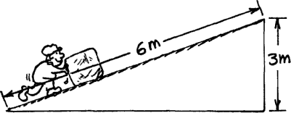

  - How much force is needed to push the ice 6 meters up the incline if you neglect friction?

  - How much work is required to push it 6 meters up the incline?

  - How much work is required to lift the block vertically 3 meters?

Refer to the following information for the next three questions.

- All of the ramps are 5 meters high. From conservation of energy, we know that the KE of the block at the bottom of the ramp will be equal to the loss of PE. Find the speed of the block at ground level in each case.

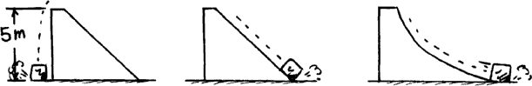
Case 1 | Case 2 | Case 3

Case 1:

Case 2:

Case 3:
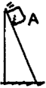
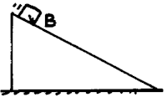
6. Refer to the following information for the next two questions.

- Which block gets to the bottom of the incline first? Assume no friction.

A | B

- Which block arrives with the greater speed? Explain your answer.

A | B | they have the same speed

Refer to the following information for the next three questions.

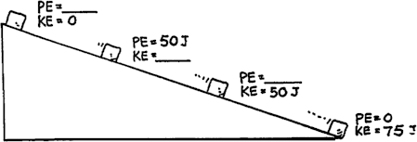
7. The KE and PE of a block freely sliding down a ramp are shown in only one place in the sketch. Fill in the missing values.

- PE top?

- KEupper middle?

- PElower middle?
Refer to the following information for the next four questions.

8. A big metal bead slides due to gravity along an upright friction-free wire. It starts from rest at the top of the wire as shown in the sketch. How fast is it traveling as it passes:

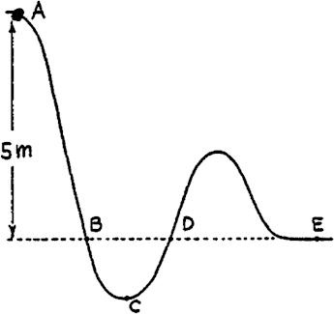

- Point B?

- Point D?

- Point E?

- At which point does it have its maximum speed?

Refer to the following information for the next question.

- Rows of wind-powered generators are used in various windy locations to generate electric power.
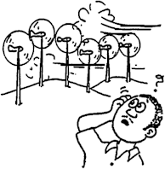

  - Does the power generated affect the speed?
  - Would locations behind the "windmills" be windier if they aren't there?
  - Discuss this in terms of energy conservation with your classmates and answer below.

Refer to the following information for the next four questions.

- A ball gains 30 J of potential energy when lifted to the top of a vertical post.
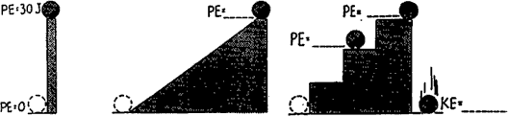

- How much potential energy will it gain if rolled to the top of an incline that is the same height as the post?

- If the ramp is then subdivided into three equally spaced steps, how much potential energy will it have on the second step?

- On the third step?

- If the ball where to fall off the back of the platform, how much kinetic energy would it have when it strikes the ground?

- A massive steel container in initially lifted to a position directly above a post that needs to be driven into the ground.

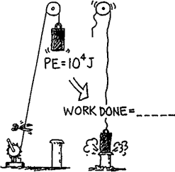

  - According to the picture, when the rope is cut, how much work will the steel container do on the post when they collide?

- A pendulum is initially displaced to a height h where it has 10 J of potential energy. After it is released, specify the amount of kinetic energy that it will have at each of the following positions in its swing. Identify the missing quantity of energy where specified.

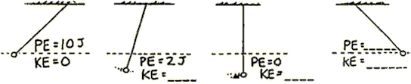

- A ball is released from rest at the top of a semi-circular ramp. And a man dives in a pool of water from a crow’s nest. Identify the missing quantity of energy where specified.

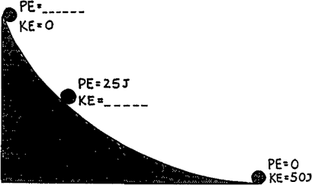
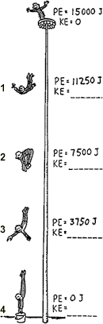

14. If a car, when moving at 30 km/hr, has 1 x 10⁶ J of kinetic energy, how much kinetic energy would it have if it doubled its speed to 60 km/hr? Tripled its speed to 90 km/hr?

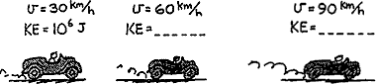

Refer to the following information for the next three questions.

15. Situation #1: This first figure shows "Newton's Mountain," so high that its top is above the drag of the atmosphere. The cannonball is fired and hits the ground as shown.

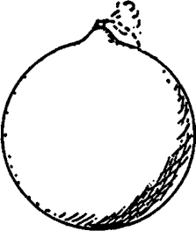
  - Describe its path as the cannon is fired faster and faster, but still less than 8 km/s.

  - What is the shape of its trajectory when it is fired at exactly 8 km/s? Why?

  - What would be the shape of the orbital path if the cannonball were fired at a speed of about 9 km/s?

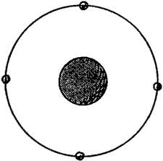
Refer to the following information for the next seven questions.

16. Situation #2: This second figure shows a satellite in circular orbit.
- Draw at each of the four positions a vector that represents the gravitational force, F, exerted on the satellite. Then draw at each position a vector that represents the velocity, v, of the satellite.

- Are all four force vectors the same length? Why or why not?

- Are all four velocity vectors the same length? Why or why not?

- What is the angle between each set of F and v vectors? Is there any component of F along v?

- What does this tell you about the work the force of gravity does on the satellite?

- Does the KE of the satellite remain constant, or does it vary?

- Does the PE of the satellite remain constant, or does it vary?
Refer to the following information for the next nine questions.

17. Situation #3: This final figure shows a satellite in elliptical orbit.

- Repeat the procedure you used for the circular orbit, mentally drawing vectors F and v for each position shown.

- Are your vectors F all the same magnitude? Why or why not?

- Are your vectors v all the same magnitude? Why or why not?

- Is the angle between vectors F and v everywhere the same, or does it vary?

- Are there places where there is a component of F along v?

- Is work done on the satellite when there is a component of F along and in the same direction of
v?

- If so, what happens to the KE of the satellite?

- When there is a component of F along and opposite to the direction of v, what happens to the KE of the satellite?

- What can you say about the sum KE + PE along the orbit?

Refer to the following information for the next table and five questions.

Bronco Brown wants to put Ft = Δmv to the test and try bungee jumping. Bronco leaps from a high cliff and experiences free fall for 3 seconds. Then the bungee cord begins to stretch, reducing his speed to zero in 2 seconds. Fortunately, the cord stretches to maximum length just short of the ground below.
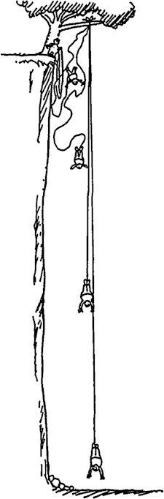

18. In the table provided below, the first blank in each row is for Bronco Brown's instantaneous velocity at the time specified. The second blank is for his instantaneous momentum.

Use the magnitude of the acceleration of gravity (g) to be 10 m/sec². Express values in SI units: distance in m, velocity in m/sec, momentum in kg m/sec, impulse in N sec, and acceleration in m/sec². Bronco's mass is 100 kg.
TIME (SEC) | Inst. Velocity (m/s) | Inst. Momentum (kgm/s)
1.0
2.0
3.0
4.0
5.0

Using the data from the table above, complete these summary questions regarding Bronco's
momentum, the impulse he received, and the average force he experienced.

  - The 3-second freefall distance of Bronco just before the bungee cord begins to stretch equals .

  - Δmv during the 3-second interval of freefall equals .

  - Δmv during the 2-second interval of slowing down equals .

  - Impulse during the 2-second interval of slowing down equals

.

e. Average force exerted by the cord during the 2-second interval of slowing down equals .

Refer to the following information for the next three questions.

19. Now what about work and energy during his fall?
a. How much KE does Bronco have 3 seconds after his jump?

- How much did his gravitational PE decrease during these 3 seconds?

- What two kinds of PE are changing during the final two-second slowing-down interval?

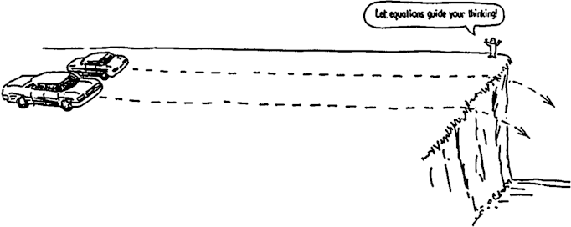
Refer to the following information for the next sixteen questions.

20. A Honda Civic and a Lincoln Town Car are initially at rest on a horizontal parking lot at the edge of a steep cliff. For simplicity, we assume that the Town Car has twice as much mass as the Civic. Equal constant forces are applied to each car and they accelerate across equal distances (we ignore the effects of friction). When they reach the far end of the lot the force is suddenly removed, whereupon they sail through the air and crash to the ground below. (The cars are beat up to begin with, and this is a scientific experiment!)

- Which car has the greater acceleration?

Honda Civic | Lincoln Town Car | both cars are the same

- Which car spends more time along the surface of the lot?

Honda Civic | Lincoln Town Car | both cars are the same

- Which car is moving faster when it reaches the edge of the cliff?

Honda Civic | Lincoln Town Car | both cars are the same

- Which car has the larger impulse imparted to it by the applied force?

Honda Civic | Lincoln Town Car | both cars are the same

Defend your answer.

- Which car has the greater momentum at the edge of the cliff?

Honda Civic | Lincoln Town Car | both cars are the same

Defend your answer.

- Which car has the greater work done on it by the applied force?

Honda Civic | Lincoln Town Car | both cars are the same

Defend your answer in terms of the distance traveled.

- Which car has the greater kinetic energy at the edge of the cliff?

Honda Civic | Lincoln Town Car | both cars are the same

- Does this answer follow from your explanation regarding the work done on the cars?

yes | no

- Does it contradict your answer with regard to which car received the greater impulse?

yes | no

Why or why not?

- Which car spends more time in the air, from the edge of the cliff to the ground below?

Honda Civic | Lincoln Town Car | both cars are the same

- Which car lands farthest horizontally from the edge of the cliff onto the ground below?

Honda Civic | Lincoln Town Car | both cars are the same

Challenge: l. Suppose the slower car crashes a horizontal distance of 10 m from the ledge. Then at what horizontal distance does the faster car hit?

- A book weighing 18.0 N is lifted from the floor and placed on a shelf 1.5 m high. What is the minimum amount of work required to accomplish this task?

A. 12 J | B. 27 J | C. 120 J | D. 270 J

- Neglecting air resistance, which of the following statements describes the change in energy of a diver who falls downward toward a swimming pool?

A. Potential energy increases, kinetic energy increases, and total energy increases.
B. Potential energy decreases, kinetic energy decreases, and total energy decreases.
C. Potential energy decreases, kinetic energy increases, and total energy remains the same.
D. Potential energy increases, kinetic energy decreases, and total energy remains the same

- The power supplied to a light bulb is 100 W. How much electrical energy is used by this light bulb in 20 s?

A. 5 J | B. 100 J | C. 500 J | D. 2000 J

- The diagram below shows a section of a roller coaster track. Five points on the track are labeled.
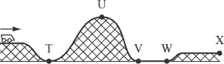

Between which two points will the roller coaster’s gravitational potential energy be converted into kinetic energy?

A. T and U | B. U and V | C. V and W | D. W and X

Refer to the following information for the next four questions.

25. A 50 kg student climbs 3 m to the top of a set of stairs.
- Calculate the change in the student’s gravitational potential energy from the bottom to the top of the stairs. Show your calculations and include units in your answer.

- How much total work does the student do while climbing the stairs? Show your calculations or explain your reasoning. Include units in your answer.

It takes the student 30 seconds to climb to the top of the stairs.

- What is the average power generated by the student climbing the stairs? Show your calculations and include units in your answer.

The next day the student carries a 10 kg backpack up the same stairs and again takes 30 seconds to reach the top of the stairs.

- Is the average power you calculated in part (c) greater than, less than, or equal to the average power the student generated the next day? Explain your answer.

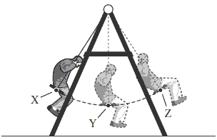
Refer to the following information for the next four questions.

26. A 70 kg person is swinging on a swing set, as shown in the diagram below. Positions X and Z represent the highest points of the person’s motion, and position Y represents the lowest point of the person’s motion.

- At which position does the person have maximum kinetic energy? Explain your answer.

- Neglecting friction, describe the energy conversion as the person travels from position X to position Y.

- The person is 1.0 m above the ground at position Y and 1.5 m above the ground at position Z. Neglecting friction, calculate the change in gravitational potential energy as the person swings from position Y to position Z. Show your calculations and include units in your answer.

- Neglecting friction, calculate the speed of the person at position Y. Show your calculations and include units in your answer.

